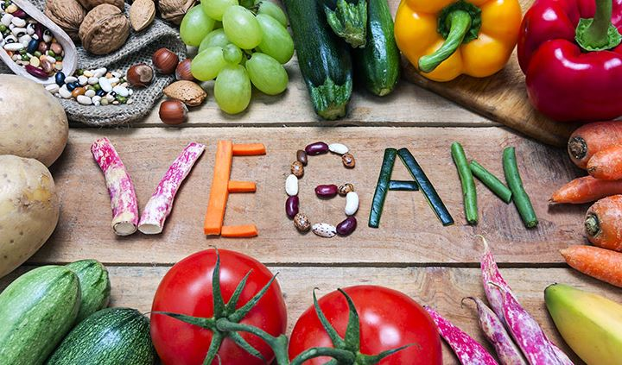**Vegan Diet- Benefits, Side Effects and Treatment**

Benefits and risks of vegan diet are secondary; first let us know what a vegan diet is. Vegan diet is a diet plan excluding all forms of animal products such as meat, eggs and dairy products.

Vegan diet is highly influenced by the approach that man’s greed should not sacrifice other lives on Earth. People following vegan diets are the ones who are concerned about the current scenario or people who want to reinstall ethics in the society and some people become vegans to accomplish their health goals.

What are the benefits and risks of vegan diet? How vegan diet benefits in accomplishing health goals? What is the vegan diet good for? Let’s find out.

**What is the vegan diet good for?**

If a diet is plant-based, it becomes 2 times healthier than the diet we take on a regular basis. A Vegan diet benefits in many ways. It reduces risk of type 2 diabetes, cardiovascular disease, hypertension, stroke, obesity etc.

Star point is that a vegan diet benefits everyone irrespective of age, including children, pregnant ladies and old aged people.

But there are certain problems with vegan diet which need to be noted. What is the vegan diet good for if it contains risks? Is vegan diet unhealthy? If yes, what are the drawbacks of vegan diet? And, why vegan diet is bad? Have a look.

**Is vegan diet unhealthy?**

Although it is healthier to include fruits and vegetables in your diet, but excluding dairy and meat completely is not a good choice either. Is vegan diet unhealthy then? Not completely. There’s a reason why vegan diet is bad. Disadvantages of vegan diet make it inferior among other diet plans.

Studies show that vegans tend to be more nutrient-deficient as compared to non-vegans. Especially people struggling from health issues like anemia or being underweight should consult a specialist before taking a vegan diet. That’s why vegan diet is bad considering certain situations. What are the problems with vegan diet?

**Problems with vegan diet**

Benefits and risks of vegan diet go hand in hand. Before switching to a vegan diet, drawbacks of vegan diet are a necessity to look upon. There are certain disadvantages of vegan diet that you should keep in mind:

* **Protein deficiency**

Protein deficiency means lack of amino acids in muscles which are responsible for proper metabolism. Minimizing intake of proteins can cause weakness in muscles, mood swings, cognitive changes etc. This adds up to disadvantages of vegan diet.

* **Vitamin B12 deficiency**

Vitamin B12 is found in dairy products, meat, fish and eggs. A vegan diet completely excludes intake of animal produces, due to which vegans require supplements to provide sufficient amount of Vitamin B12 in their body. This adds up to negatives of vegan diet.

* **Lower intake of essential nutrients**

Other nutrients like zinc, calcium and omega-3 fatty acids are not found in a vegan diet. This adds up to negatives of vegan diet.

* **Higher intake of anti-nutrients**

Anti-nutrients like phytic acid inhibit digestion of essential nutrients by blocking digestive enzymes. This adds up to negatives of vegan diet.

* **Overconsumption of carbs**

A balanced diet is necessary in all circumstances whether you are a vegan or not. Due to limited sources available, vegans are found to eat higher amount of carbs. This is not a good practice as eating too many carbs can cause yeast overgrowth and body weight gain.

* **Fatigue and exhaustion**

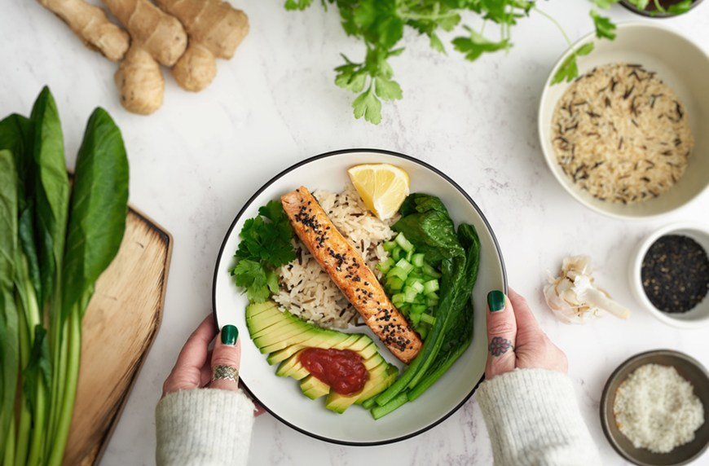This is usually lack of certain minerals and vitamins mostly iron and B vitamins. These nutrients are exclusively found in meat and fish.

**Vegan diet side effects treatment**

No such treatment is required if there are no serious issues. Only the side effects need to be addressed. Vegan diet side effects treatment includes the following steps:

* **Eat vitamin C rich food**

When on a diet, our body removes toxins and some changes might be visible. But the piled-up dirt needs to be sorted! Vitamin C increases the detoxification process and helps clearing up the skin faster.

* **Don’t forget to take omega-3 fats**

These omega-3 fats heal inner organs and skin, reduce inflammation and help in stabilizing blood sugar levels.

* **Choose from a variety of greens**

You’ve got a variety of ingredients in fruits and vegetables. Find some delicious recipes and try out making yours! A healthy food recipe is yet to be explored.

Vegan diet side effects treatment is to cure some minor side effects. For major problems, consult a doctor.

**Conclusion**

There are benefits and risks in everything we choose. Similarly, there are benefits and risks of vegan diet. If we balance the benefits and risks of vegan diet, we can surely receive its benefits. There are associated drawbacks of vegan diet but that aren’t enough to put a vegan diet down in a list. Keep in mind all the benefits and risks of vegan diet and then choose whether to take it or not.